# COMP 3133 – Full Stack Development – II

# ASSIGNMENT-1

# REQUIRED SCREENSHOTS

# MUTATION SIGNUP

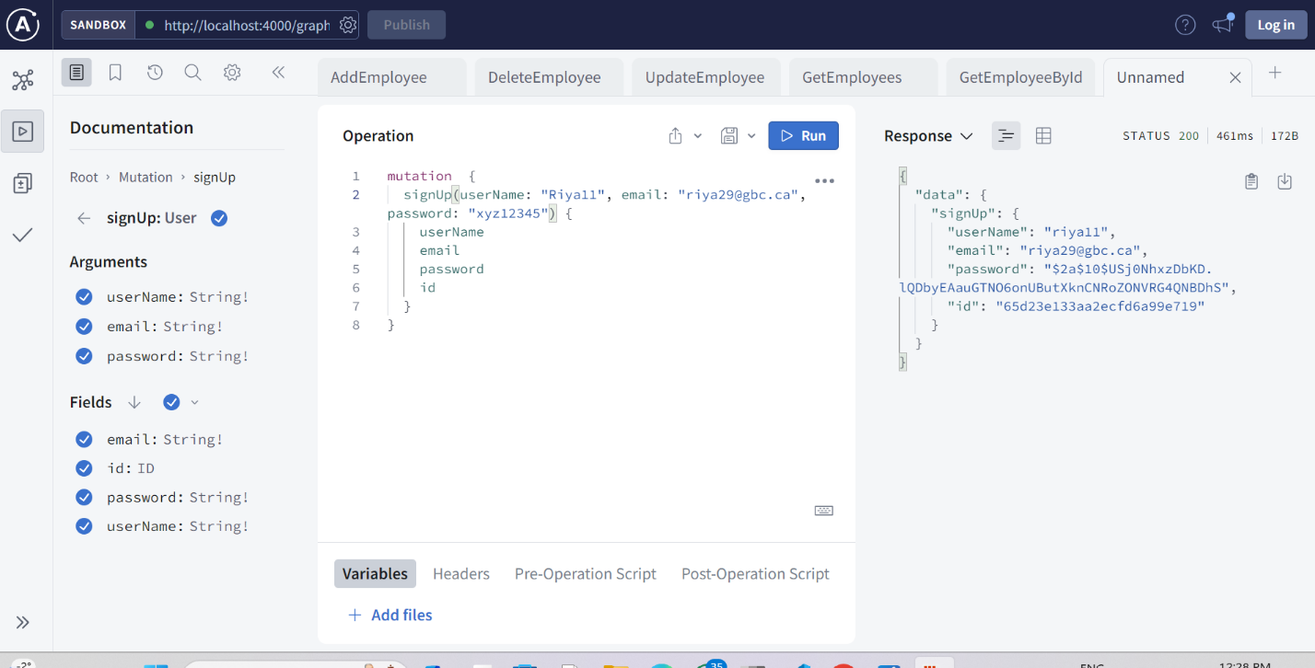

# Query Login

# Query Get all employees

# Mutation Add New employee

# Query Search employee by eid

1. Mutation Delete employee by eid A screenshot of a computer

   Description automatically generated

# MONGODB USER

